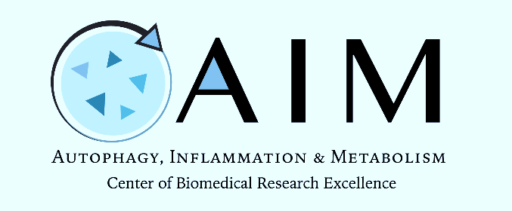
AIM Core Facility Open House Workshop
Date: June 20 – 28, 2023
Time: see below
Location: Zoom & AIM Core Facility (Fitz 384, 389, 301a/b)
Zoomlink: https://hsc-unm.zoom.us/j/95734293241

AIM Scientific Core Facility Personnel:

Judy Cannon, Ph.D.  Core Director | Meilian Liu, Ph.D.  Core Co-Director
Sharina Desai, Ph.D.  Core Technical Director | Li Chen, Ph.D.  Core Co-Technical Director

DATE | TIME & TOPIC | PRESENTERS
Tuesday June 20, 2023 | BREAKFAST on own
 | 9:30 am – 10:00 am - AIM Core Open House Welcome & Overview | Drs. Judy Cannon, Meilian Liu, Sharina Desai, and Li Chen
 | 10:00 am – 10:30 am - Isoplexis in Focus – User talks | Dr. Yamhilette Licon Munoz (Dr. Sara Piccirillo Lab)
 | 10:30 am – 11:30 am - Isoplexis Tech Talk | Lisa English
 | 12 pm – 1 pm LUNCH on own
 | 1:00 pm – 2:00 pm– Isoplexis Demo & Data Analysis with Kebba Mbye | Lisa English & Kebba Mbye
DATE | TIME & TOPIC | PRESENTERS
Wednesday June 21, 2023 | BREAKFAST on own
 | 9:30 am – 10:00 am - AMNIS Focus - User talks | Dr. Fulong Wang (Dr. Vojo Deretic Lab), (Dr. Tamara Roitbak & Dr. Guanghua Wan – Presented by Dr. Desai)
 | 10:00 am – 11:00 am - Cytek in Focus (Tech Talk) | Dr. Manuel Noben
 | 12 pm – 1 pm LUNCH on own
 | 1:00 pm – 4:00 pm – Open Consultations with Isoplexis Team & Data Analysis with Cytek Team | Isoplexis Team & Cytek Team
DATE | TIME & TOPIC | PRESENTERS
Thursday June 22, 2023 | BREAKFAST on own
 | 9:30 am – 4:00 pm – Amnis Data Analysis | Dr. Manuel Noben (Dr. Guanghua Wan & Seth Merkley)
 | 12 pm – 1 pm LUNCH on own
DATE | TIME &TOPIC |  | PRESENTERS
Monday June 26, 2023 | BREAKFAST on own
 | 9:30 am – 10:00 am – Seahorse Focus - User talks |  | Seth Merkley (Dr. Dario Marchetti)
 | 10:00 am – 11:00 am – (Seahorse) Agilent in Focus |  | Craig Smith
 | 12 pm – 1 pm LUNCH on own
DATE | TIME & TOPIC |  | PRESENTERS
Tuesday June 27, 2023 | BREAKFAST on own
 | 9:30 am -10:30 am – CX7 Focus - User talks |  | Dr. Jing Pu, Dr. Mike Mandell, Dr. Rahul Kumar, Dr. Mijung Oh & Dr. Paul Mrass
 | 10:30 am – 11:30 am – HCA Team |  | Jacqulyn Tolson & Mark Clark
 | 11:30 am 12:30 pm – Zeiss confocal as a continuum of HCM imaging |  | Dr. Geert Vreede

*Breakfast (before 9:30) and lunch (12-1 pm) both on own (suggestions for visitors: Happy Heart Bistro).

